**Exp No 8: Practice Queries using Aggregate functions, Group By, Having Clause and Order by Clause**.

->**Count**

**->** SELECT COUNT(ProductName) FROM Products;

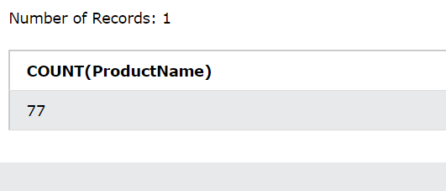

**->Avg**

**->** SELECT AVG(Price) FROM Products;

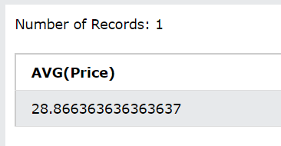

-> **Sum**

->SELECT SUM(Quantity) FROM OrderDetails;

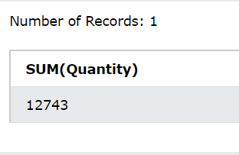

**->Min**

**->**SELECT MIN(Price) AS SmallestPrice FROM Products;

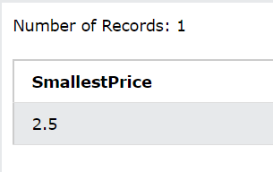

->**Max**

->SELECT MAX(Price) AS LargestPrice FROM Products;



->**Group by**

->SELECT COUNT(CustomerID), Country FROM Customers GROUP BY Country like '%o';

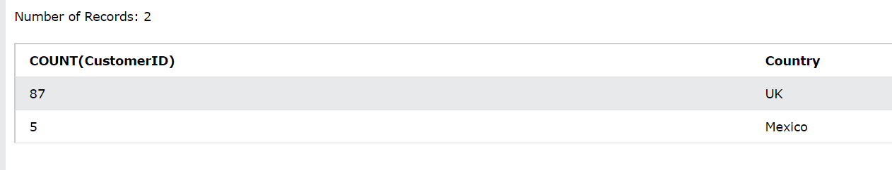

->**Having count**

->SELECT COUNT(CustomerID), Country FROM Customers GROUP BY Country HAVING COUNT(CustomerID) > 5;

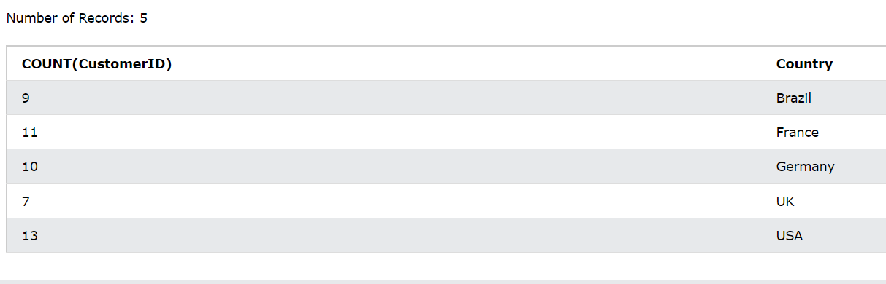

->**Order by**

->SELECT * FROM Customers where CustomerID < 5 ORDER BY Country;



